Contents

TOKEN 2

# WEB 3.0

web 1.0 -> web 2.0 ->

google

facebook

etc

http and tcp is catching 0 value. because google and facebook and many more are capturing values. Web 2.0 failed to capture value on protocol level

with Block chain it is slightly different because protocol level is where the value is captured.

For example, lets look at ETH where so many tokens are depending on one coin.

My definition of smart contract is just a small pieces of codes that is running on ETH blockchain executed by EVM while dApp (decentralized application) is more than entire experience because this smart contract might be connected to website and then you might have also have central server involved in some features so this whole thing would be called dAPP while smart contract is only a part

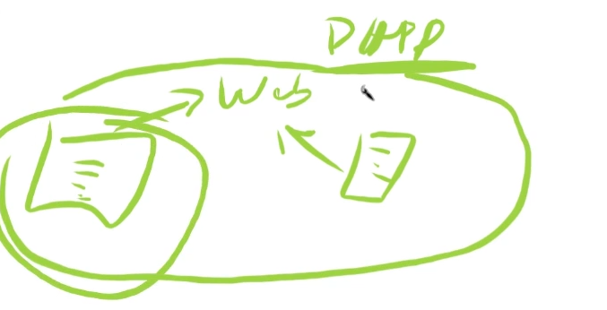

So the era we are entering right now is WEB3.0 and dAPPs being developed